Niranjan S
Superset id: 6738344
- Spring-rest-handson:
1-Create a Spring Web Project using Maven

Employee.java:
package com.cognizant.spring_learn;
import org.slf4j.Logger;
import org.slf4j.LoggerFactory;
import org.springframework.boot.SpringApplication;
import org.springframework.boot.autoconfigure.SpringBootApplication;
import org.springframework.context.ApplicationContext;
import org.springframework.context.support.ClassPathXmlApplicationContext;
@SpringBootApplication
public class SpringLearnApplication {
private static final Logger LOGGER =
LoggerFactory.getLogger(SpringLearnApplication.class);
public static void main(String[] args) {
LOGGER.info("Starting Spring Boot Application");
SpringApplication.run(SpringLearnApplication.class, args);
ApplicationContext context =
new ClassPathXmlApplicationContext("beans.xml");
Student student = context.getBean("student", Student.class);
student.display();
LOGGER.info("Application executed successfully");
}
}

SpringLearnApplication.java:
package com.cognizant.spring_learn;
import org.slf4j.Logger;
import org.slf4j.LoggerFactory;
import org.springframework.boot.SpringApplication;
import org.springframework.boot.autoconfigure.SpringBootApplication;
import org.springframework.context.ApplicationContext;
import org.springframework.context.support.ClassPathXmlApplicationContext;
@SpringBootApplication
public class SpringLearnApplication {
private static final Logger LOGGER =
LoggerFactory.getLogger(SpringLearnApplication.class);
public static void main(String[] args) {
LOGGER.info("Starting Spring Boot Application");
SpringApplication.run(SpringLearnApplication.class, args);
ApplicationContext context =
new ClassPathXmlApplicationContext("beans.xml");
Student student = context.getBean("student", Student.class);
student.display();
LOGGER.info("Application executed successfully");
}
}

Student.java:
package com.cognizant.spring_learn;
public class Student {
private String name;
private int age;
// Constructor Injection
public Student(String name, int age) {
this.name = name;
this.age = age;
}
public void display() {
System.out.println("Student Name : " + name);
System.out.println("Student Age : " + age);
}
}

beams.xml:
<?xml version="1.0" encoding="UTF-8"?>
<beans xmlns="http://www.springframework.org/schema/beans"
xmlns:xsi="http://www.w3.org/2001/XMLSchema-instance"
xsi:schemaLocation="
http://www.springframework.org/schema/beans
https://www.springframework.org/schema/beans/spring-beans.xsd">
<bean id="student"
class="com.cognizant.spring_learn.Student">
<constructor-arg value="Naveen Kumar"/>
<constructor-arg value="21"/>
</bean>
</beans>

application.properties:
server.port=8080
logging.level.root=INFO
logging.level.com.cognizant=DEBUG
logging.pattern.console=%d{yyyy-MM-dd HH:mm:ss} [%level] %msg%n

Output:
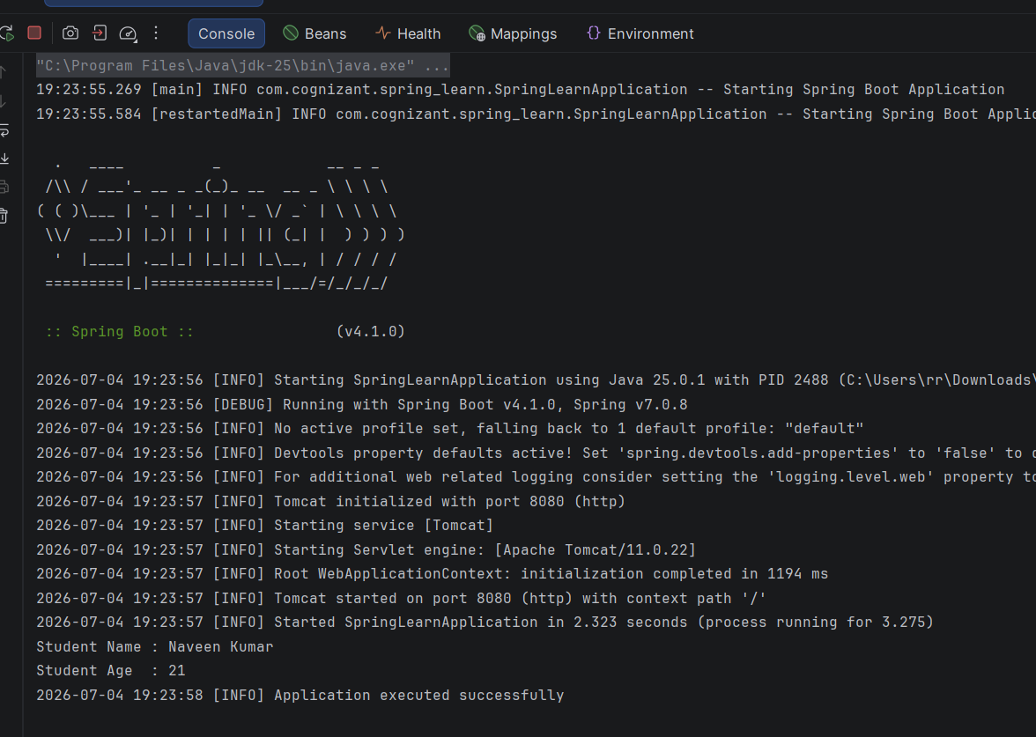

- Spring-rest-handson:
4-Spring Core – Load Country from Spring Configuration XML

Country.java:
package com.cognizant.spring_learn;
import org.slf4j.Logger;
import org.slf4j.LoggerFactory;
public class Country {
private static final Logger LOGGER =
LoggerFactory.getLogger(Country.class);
private String code;
private String name;
// Empty Constructor
public Country() {
LOGGER.debug("Inside Country Constructor.");
}
public String getCode() {
LOGGER.debug("Inside getCode()");
return code;
}
public void setCode(String code) {
LOGGER.debug("Inside setCode()");
this.code = code;
}
public String getName() {
LOGGER.debug("Inside getName()");
return name;
}
public void setName(String name) {
LOGGER.debug("Inside setName()");
this.name = name;
}
@Override
public String toString() {
return "Country [code=" + code + ", name=" + name + "]";
}
}:

country.xml:
<?xml version="1.0" encoding="UTF-8"?>
<beans xmlns="http://www.springframework.org/schema/beans"
xmlns:xsi="http://www.w3.org/2001/XMLSchema-instance"
xsi:schemaLocation="
http://www.springframework.org/schema/beans
https://www.springframework.org/schema/beans/spring-beans.xsd">
<bean id="country"
class="com.cognizant.spring_learn.Country">
<property name="code" value="IN"/>
<property name="name" value="India"/>
</bean>
</beans>

SpringLearnApplication.java:
package com.cognizant.spring_learn;
import org.slf4j.Logger;
import org.slf4j.LoggerFactory;
import org.springframework.boot.SpringApplication;
import org.springframework.boot.autoconfigure.SpringBootApplication;
import org.springframework.context.ApplicationContext;
import org.springframework.context.support.ClassPathXmlApplicationContext;
@SpringBootApplication
public class SpringLearnApplication {
private static final Logger LOGGER =
LoggerFactory.getLogger(SpringLearnApplication.class);
public static void main(String[] args) {
SpringApplication.run(SpringLearnApplication.class, args);
displayCountry();
}
public static void displayCountry() {
ApplicationContext context =
new ClassPathXmlApplicationContext("country.xml");
Country country =
context.getBean("country", Country.class);
LOGGER.debug("Country : {}", country.toString());
}
}

application.properties:
server.port=8080
logging.level.root=INFO
logging.level.com.cognizant=DEBUG
logging.pattern.console=%d{yyyy-MM-dd HH:mm:ss} [%level] %msg%n

Output:
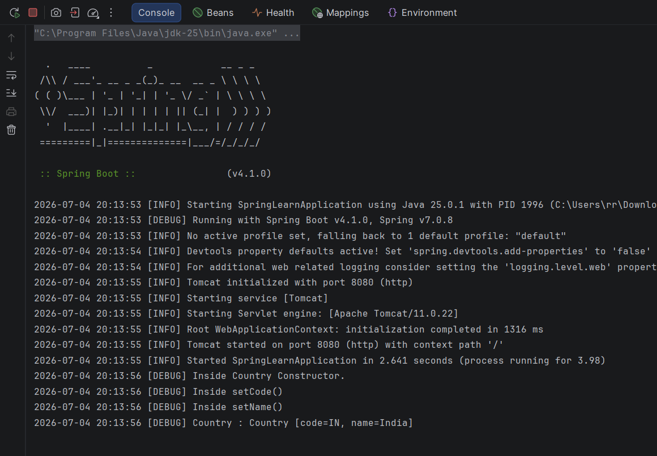

- Spring-rest-handson:
1-Hello World RESTful Web Service

HelloController.java:
package com.cognizant.spring_learn.controller;
import org.slf4j.Logger;
import org.slf4j.LoggerFactory;
import org.springframework.web.bind.annotation.GetMapping;
import org.springframework.web.bind.annotation.RestController;
@RestController
public class HelloController {
private static final Logger LOGGER =
LoggerFactory.getLogger(HelloController.class);
@GetMapping("/hello")
public String sayHello() {
LOGGER.info("START");
String message = "Hello World!!";
LOGGER.info("END");
return message;
}
}
Country.java:
package com.cognizant.spring_learn;
import org.slf4j.Logger;
import org.slf4j.LoggerFactory;
public class Country {
private static final Logger LOGGER =
LoggerFactory.getLogger(Country.class);
private String code;
private String name;
// Empty Constructor
public Country() {
LOGGER.debug("Inside Country Constructor.");
}
public String getCode() {
LOGGER.debug("Inside getCode()");
return code;
}
public void setCode(String code) {
LOGGER.debug("Inside setCode()");
this.code = code;
}
public String getName() {
LOGGER.debug("Inside getName()");
return name;
}
public void setName(String name) {
LOGGER.debug("Inside setName()");
this.name = name;
}
@Override
public String toString() {
return "Country [code=" + code + ", name=" + name + "]";
}
}

SpringLearnApplication.java:
package com.cognizant.spring_learn;
import org.slf4j.Logger;
import org.slf4j.LoggerFactory;
import org.springframework.boot.SpringApplication;
import org.springframework.boot.autoconfigure.SpringBootApplication;
import org.springframework.context.ApplicationContext;
import org.springframework.context.support.ClassPathXmlApplicationContext;
@SpringBootApplication
public class SpringLearnApplication {
private static final Logger LOGGER =
LoggerFactory.getLogger(SpringLearnApplication.class);
public static void main(String[] args) {
SpringApplication.run(SpringLearnApplication.class, args);
displayCountry();
}
public static void displayCountry() {
ApplicationContext context =
new ClassPathXmlApplicationContext("country.xml");
Country country =
context.getBean("country", Country.class);
LOGGER.debug("Country : {}", country.toString());
}
}

application.properties:
server.port=8083
logging.level.root=INFO
logging.level.com.cognizant=DEBUG
logging.pattern.console=%d{yyyy-MM-dd HH:mm:ss} [%level] %msg%n

country.xml:
<?xml version="1.0" encoding="UTF-8"?>
<beans xmlns="http://www.springframework.org/schema/beans"
xmlns:xsi="http://www.w3.org/2001/XMLSchema-instance"
xsi:schemaLocation="
http://www.springframework.org/schema/beans
https://www.springframework.org/schema/beans/spring-beans.xsd">
<bean id="country"
class="com.cognizant.spring_learn.Country">
<property name="code" value="IN"/>
<property name="name" value="India"/>
</bean>
</beans>

Output:
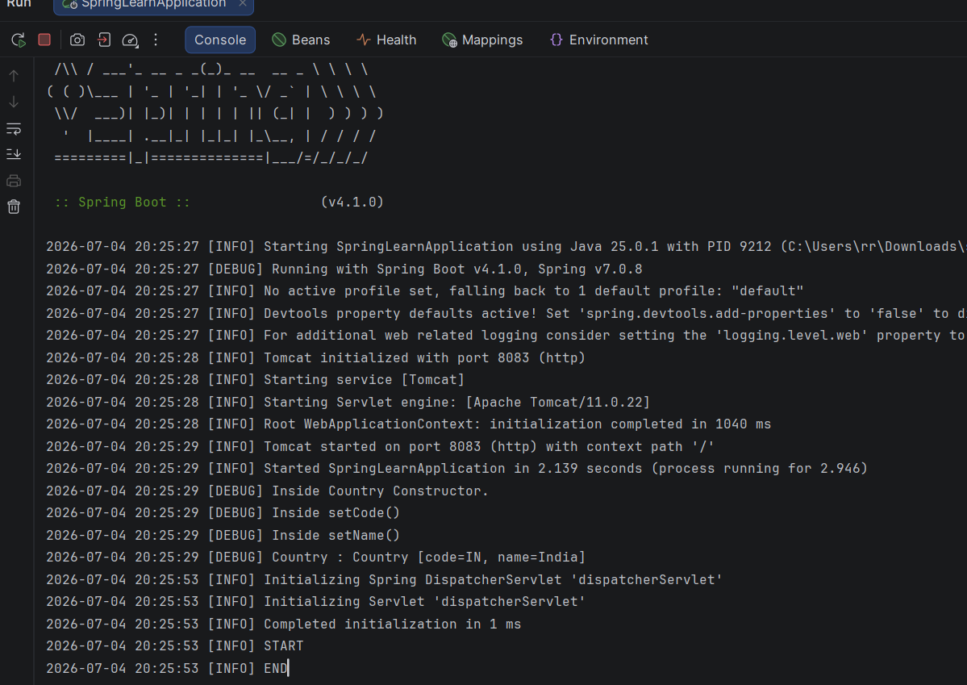

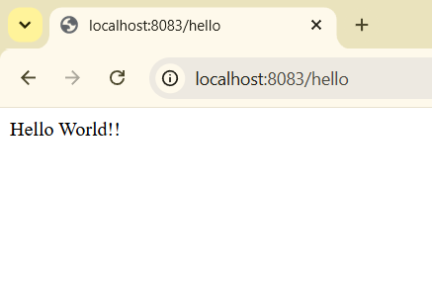
- Spring-rest-handson:
2-REST - Country Web Service

SpringLearnApplication.java:
package com.cognizant.spring_learn;
import org.slf4j.Logger;
import org.slf4j.LoggerFactory;
import org.springframework.boot.SpringApplication;
import org.springframework.boot.autoconfigure.SpringBootApplication;
import org.springframework.context.ApplicationContext;
import org.springframework.context.support.ClassPathXmlApplicationContext;
@SpringBootApplication
public class SpringLearnApplication {
private static final Logger LOGGER =
LoggerFactory.getLogger(SpringLearnApplication.class);
public static void main(String[] args) {
SpringApplication.run(SpringLearnApplication.class, args);
displayCountry();
}
public static void displayCountry() {
ApplicationContext context =
new ClassPathXmlApplicationContext("country.xml");
Country country =
context.getBean("country", Country.class);
LOGGER.debug("Country : {}", country.toString());
}
}

Country.java:
package com.cognizant.spring_learn;
import org.slf4j.Logger;
import org.slf4j.LoggerFactory;
public class Country {
private static final Logger LOGGER =
LoggerFactory.getLogger(Country.class);
private String code;
private String name;
// Empty Constructor
public Country() {
LOGGER.debug("Inside Country Constructor.");
}
public String getCode() {
LOGGER.debug("Inside getCode()");
return code;
}
public void setCode(String code) {
LOGGER.debug("Inside setCode()");
this.code = code;
}
public String getName() {
LOGGER.debug("Inside getName()");
return name;
}
public void setName(String name) {
LOGGER.debug("Inside setName()");
this.name = name;
}
@Override
public String toString() {
return "Country [code=" + code + ", name=" + name + "]";
}
}

HelloController.java:
package com.cognizant.spring_learn.controller;
import org.slf4j.Logger;
import org.slf4j.LoggerFactory;
import org.springframework.web.bind.annotation.GetMapping;
import org.springframework.web.bind.annotation.RestController;
@RestController
public class HelloController {
private static final Logger LOGGER =
LoggerFactory.getLogger(HelloController.class);
@GetMapping("/hello")
public String sayHello() {
LOGGER.info("START");
String message = "Hello World!!";
LOGGER.info("END");
return message;
}
}

CountryController.java:
package com.cognizant.spring_learn.controller;
import com.cognizant.spring_learn.Country;
import org.springframework.context.ApplicationContext;
import org.springframework.context.support.ClassPathXmlApplicationContext;
import org.springframework.web.bind.annotation.RequestMapping;
import org.springframework.web.bind.annotation.RestController;
@RestController
public class CountryController {
@RequestMapping("/country")
public Country getCountryIndia() {
ApplicationContext context =
new ClassPathXmlApplicationContext("country.xml");
Country country =
context.getBean("country", Country.class);
return country;
}
}

application.properties:
server.port=8083
logging.level.root=INFO
logging.level.com.cognizant=DEBUG
logging.pattern.console=%d{yyyy-MM-dd HH:mm:ss} [%level] %msg%n

country.xml:
<?xml version="1.0" encoding="UTF-8"?>
<beans xmlns="http://www.springframework.org/schema/beans"
xmlns:xsi="http://www.w3.org/2001/XMLSchema-instance"
xsi:schemaLocation="
http://www.springframework.org/schema/beans
https://www.springframework.org/schema/beans/spring-beans.xsd">
<bean id="country"
class="com.cognizant.spring_learn.Country">
<property name="code" value="IN"/>
<property name="name" value="India"/>
</bean>
</beans>

Output:
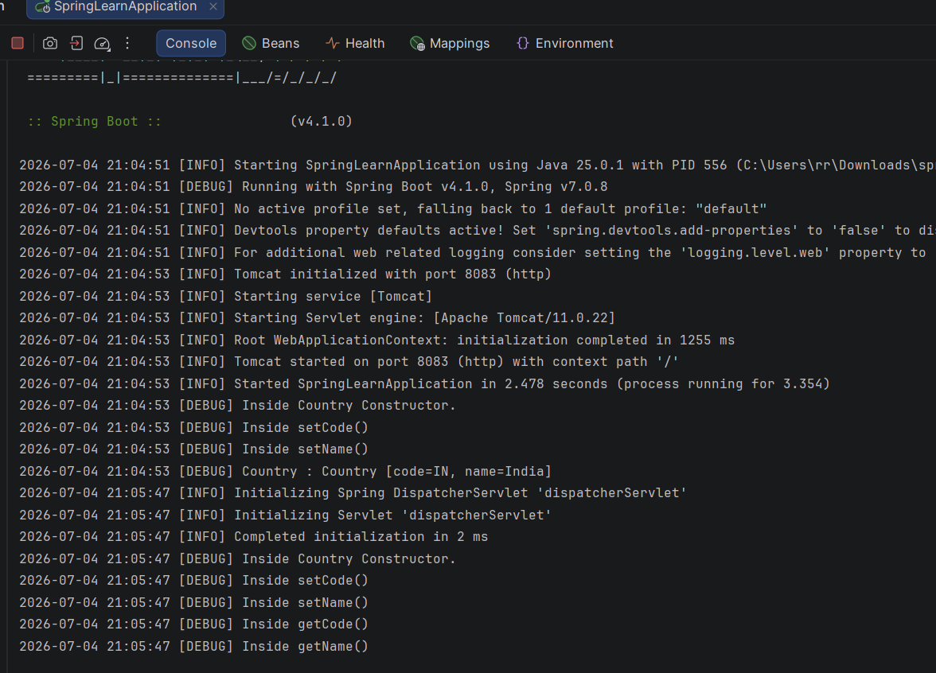

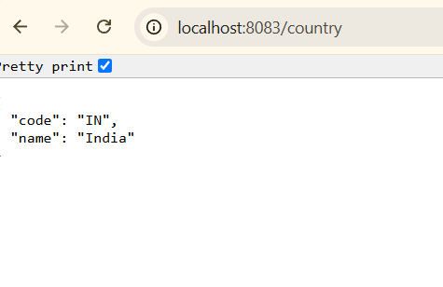
2) Spring-rest-handson:
3-REST - Get country based on country code
HelloController.java:
package com.cognizant.spring_learn;
import org.slf4j.Logger;
import org.slf4j.LoggerFactory;
import org.springframework.boot.SpringApplication;
import org.springframework.boot.autoconfigure.SpringBootApplication;
import org.springframework.context.ApplicationContext;
import org.springframework.context.support.ClassPathXmlApplicationContext;
@SpringBootApplication
public class SpringLearnApplication {
private static final Logger LOGGER =
LoggerFactory.getLogger(SpringLearnApplication.class);
public static void main(String[] args) {
SpringApplication.run(SpringLearnApplication.class, args);
}
public static void displayCountry() {
ApplicationContext context =
new ClassPathXmlApplicationContext("country.xml");
Country country =
context.getBean("country", Country.class);
LOGGER.debug("Country : {}", country.toString());
}
}

CountryController.java:
package com.cognizant.spring_learn.controller;
import com.cognizant.spring_learn.Country;
import com.cognizant.spring_learn.service.CountryService;
import org.springframework.beans.factory.annotation.Autowired;
import org.springframework.web.bind.annotation.GetMapping;
import org.springframework.web.bind.annotation.PathVariable;
import org.springframework.web.bind.annotation.RestController;
@RestController
public class CountryController {
@Autowired
private CountryService countryService;
@GetMapping("/countries/{code}")
public Country getCountry(@PathVariable String code) {
return countryService.getCountry(code);
}
}

CountryService.java:
package com.cognizant.spring_learn.service;
import com.cognizant.spring_learn.Country;
import org.springframework.context.ApplicationContext;
import org.springframework.context.support.ClassPathXmlApplicationContext;
import org.springframework.stereotype.Service;
import java.util.List;
@Service
public class CountryService {
public Country getCountry(String code) {
ApplicationContext context =
new ClassPathXmlApplicationContext("country.xml");
List<Country> countryList =
(List<Country>) context.getBean("countryList");
for (Country country : countryList) {
if (country.getCode().equalsIgnoreCase(code)) {
return country;
}
}
return null;
}
}

Country.java:
package com.cognizant.spring_learn;
import org.slf4j.Logger;
import org.slf4j.LoggerFactory;
public class Country {
private static final Logger LOGGER =
LoggerFactory.getLogger(Country.class);
private String code;
private String name;
// Empty Constructor
public Country() {
LOGGER.debug("Inside Country Constructor.");
}
public String getCode() {
LOGGER.debug("Inside getCode()");
return code;
}
public void setCode(String code) {
LOGGER.debug("Inside setCode()");
this.code = code;
}
public String getName() {
LOGGER.debug("Inside getName()");
return name;
}
public void setName(String name) {
LOGGER.debug("Inside setName()");
this.name = name;
}
@Override
public String toString() {
return "Country [code=" + code + ", name=" + name + "]";
}
}

SpringLearnApplication.java:
package com.cognizant.spring_learn;
import org.slf4j.Logger;
import org.slf4j.LoggerFactory;
import org.springframework.boot.SpringApplication;
import org.springframework.boot.autoconfigure.SpringBootApplication;
import org.springframework.context.ApplicationContext;
import org.springframework.context.support.ClassPathXmlApplicationContext;
@SpringBootApplication
public class SpringLearnApplication {
private static final Logger LOGGER =
LoggerFactory.getLogger(SpringLearnApplication.class);
public static void main(String[] args) {
SpringApplication.run(SpringLearnApplication.class, args);
}
public static void displayCountry() {
ApplicationContext context =
new ClassPathXmlApplicationContext("country.xml");
Country country =
context.getBean("country", Country.class);
LOGGER.debug("Country : {}", country.toString());
}
}

country.xml:
<?xml version="1.0" encoding="UTF-8"?>
<beans xmlns="http://www.springframework.org/schema/beans"
xmlns:xsi="http://www.w3.org/2001/XMLSchema-instance"
xsi:schemaLocation="
http://www.springframework.org/schema/beans
https://www.springframework.org/schema/beans/spring-beans.xsd">
<bean id="countryList" class="java.util.ArrayList">
<constructor-arg>
<list>
<bean class="com.cognizant.spring_learn.Country">
<property name="code" value="US"/>
<property name="name" value="United States"/>
</bean>
<bean class="com.cognizant.spring_learn.Country">
<property name="code" value="DE"/>
<property name="name" value="Germany"/>
</bean>
<bean class="com.cognizant.spring_learn.Country">
<property name="code" value="IN"/>
<property name="name" value="India"/>
</bean>
<bean class="com.cognizant.spring_learn.Country">
<property name="code" value="JP"/>
<property name="name" value="Japan"/>
</bean>
</list>
</constructor-arg>
</bean>
</beans>

application.properties:
server.port=8083
logging.level.root=INFO
logging.level.com.cognizant=DEBUG
logging.pattern.console=%d{yyyy-MM-dd HH:mm:ss} [%level] %msg%n

Output:
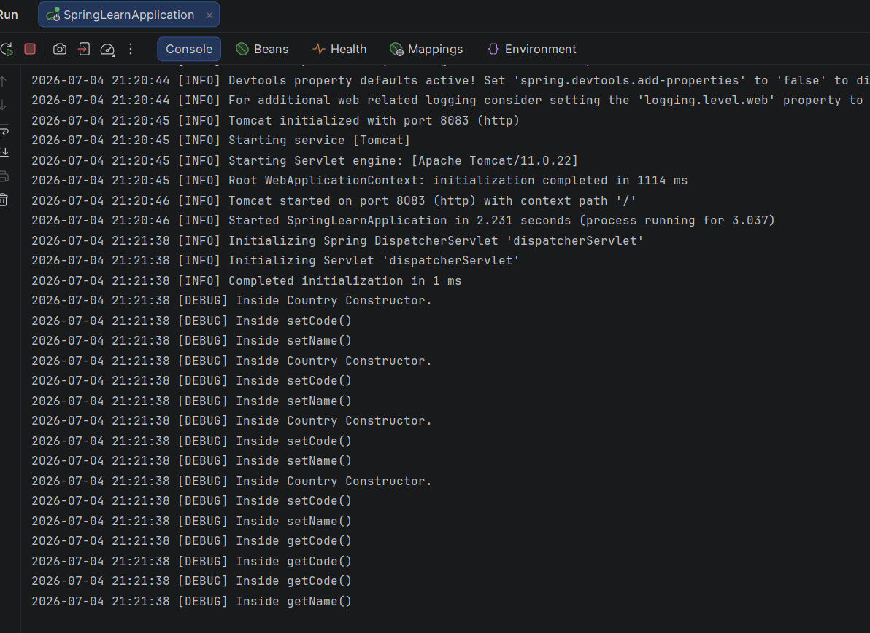

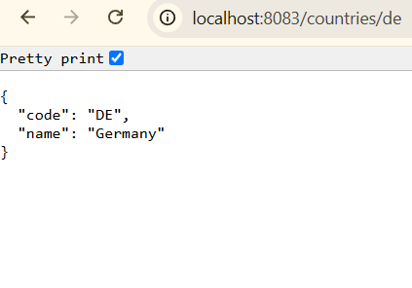

5)JWT-handson:
Create authentication service that returns JWT:
1)Create authentication controller and configure it in SecurityConfig

AuthenticationController.java:
package com.cognizant.springlearn.controller;
import java.util.HashMap;
import java.util.Map;
import org.slf4j.Logger;
import org.slf4j.LoggerFactory;
import org.springframework.web.bind.annotation.GetMapping;
import org.springframework.web.bind.annotation.RequestHeader;
import org.springframework.web.bind.annotation.RestController;
@RestController
public class AuthenticationController {
private static final Logger LOGGER =
LoggerFactory.getLogger(AuthenticationController.class);
@GetMapping("/authenticate")
public Map<String, String> authenticate(
@RequestHeader("Authorization") String authHeader) {
LOGGER.info("START");
LOGGER.debug("Authorization Header : {}", authHeader);
Map<String, String> map = new HashMap<>();
map.put("token", "");
LOGGER.info("END");
return map;
}
}

SecurityConfig.java:
package com.cognizant.springlearn.config;
import org.springframework.context.annotation.Bean;
import org.springframework.context.annotation.Configuration;
import org.springframework.security.config.Customizer;
import org.springframework.security.config.annotation.web.builders.HttpSecurity;
import org.springframework.security.core.userdetails.User;
import org.springframework.security.core.userdetails.UserDetails;
import org.springframework.security.provisioning.InMemoryUserDetailsManager;
import org.springframework.security.web.SecurityFilterChain;
@Configuration
public class SecurityConfig {
@Bean
public InMemoryUserDetailsManager userDetailsService() {
UserDetails user = User.withUsername("user")
.password("{noop}pwd")
.roles("USER")
.build();
UserDetails admin = User.withUsername("admin")
.password("{noop}pwd")
.roles("ADMIN")
.build();
return new InMemoryUserDetailsManager(user, admin);
}
@Bean
public SecurityFilterChain filterChain(HttpSecurity http)
throws Exception {
http.csrf(csrf -> csrf.disable())
.authorizeHttpRequests(auth -> auth
.requestMatchers("/countries").hasRole("USER")
.requestMatchers("/authenticate")
.hasAnyRole("USER", "ADMIN")
.anyRequest().authenticated())
.httpBasic(Customizer.withDefaults());
return http.build();
}
}

SpringlearnApplication.java:
package com.cognizant.springlearn;
import org.springframework.boot.SpringApplication;
import org.springframework.boot.autoconfigure.SpringBootApplication;
@SpringBootApplication
public class SpringlearnApplication {
public static void main(String[] args) {
SpringApplication.run(SpringlearnApplication.class, args);
}
}

application.yaml:
server:
port: 8090
logging:
level:
com.cognizant.springlearn: DEBUG

Output:
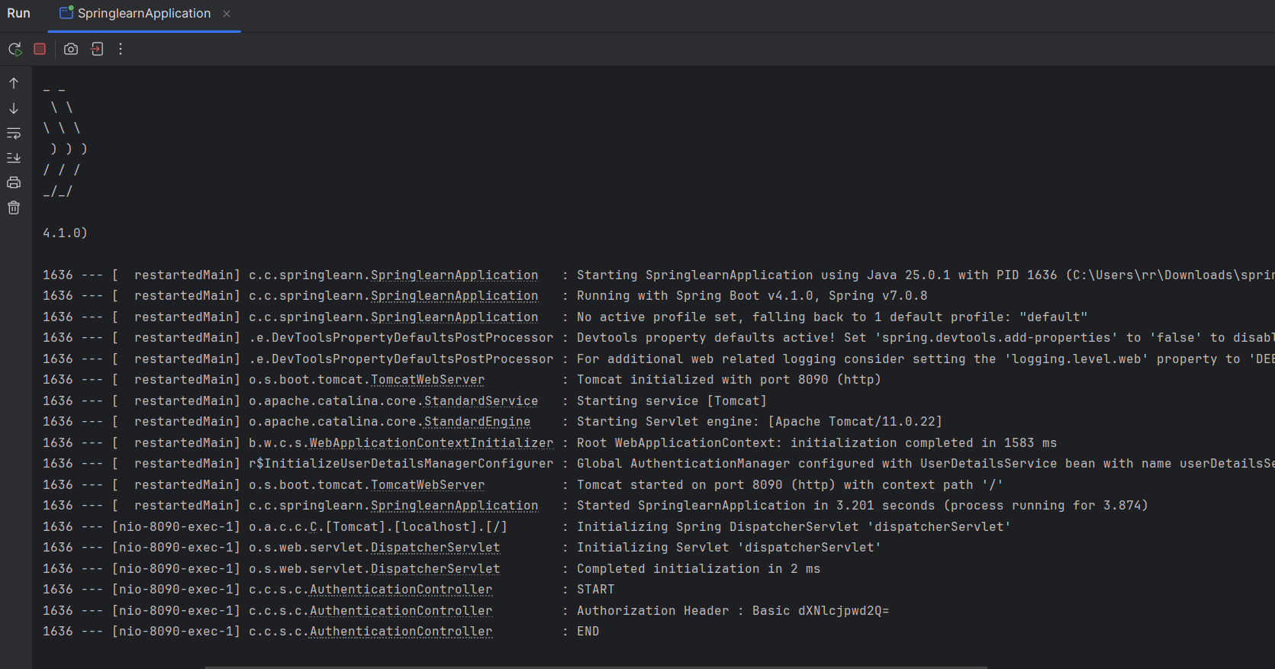
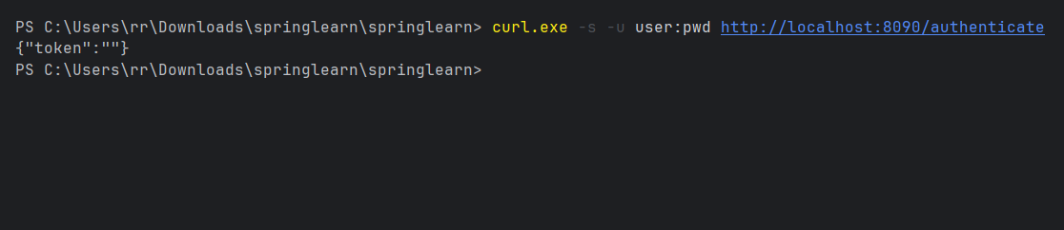

5) 2-Read Authorization header and decode the username and password
SpringlearnApplication.java:
package com.cognizant.springlearn;
import org.springframework.boot.SpringApplication;
import org.springframework.boot.autoconfigure.SpringBootApplication;
@SpringBootApplication
public class SpringlearnApplication {
public static void main(String[] args) {
SpringApplication.run(SpringlearnApplication.class, args);
}
}

AuthenticationController.java:
package com.cognizant.springlearn.controller;
import java.nio.charset.StandardCharsets;
import java.util.Base64;
import java.util.HashMap;
import java.util.Map;
import org.slf4j.Logger;
import org.slf4j.LoggerFactory;
import org.springframework.web.bind.annotation.GetMapping;
import org.springframework.web.bind.annotation.RequestHeader;
import org.springframework.web.bind.annotation.RestController;
@RestController
public class AuthenticationController {
private static final Logger LOGGER =
LoggerFactory.getLogger(AuthenticationController.class);
@GetMapping("/authenticate")
public Map<String, String> authenticate(
@RequestHeader("Authorization") String authHeader) {
LOGGER.info("START");
LOGGER.debug("Authorization Header : {}", authHeader);
// Call the method to extract username
String user = getUser(authHeader);
LOGGER.debug("User : {}", user);
Map<String, String> map = new HashMap<>();
map.put("token", "");
LOGGER.info("END");
return map;
}
// Private method to decode the Authorization header
private String getUser(String authHeader) {
LOGGER.debug("Inside getUser()");
// Remove "Basic "
String encodedCredentials = authHeader.substring(6);
LOGGER.debug("Encoded Credentials : {}", encodedCredentials);
// Decode Base64
byte[] decodedBytes = Base64.getDecoder().decode(encodedCredentials);
String decodedString = new String(decodedBytes, StandardCharsets.UTF_8);
LOGGER.debug("Decoded String : {}", decodedString);
// Get username before ':'
String user = decodedString.substring(0, decodedString.indexOf(":"));
LOGGER.debug("Extracted User : {}", user);
return user;
}
}

SecurityConfig.java:
package com.cognizant.springlearn.config;
import org.springframework.context.annotation.Bean;
import org.springframework.context.annotation.Configuration;
import org.springframework.security.config.Customizer;
import org.springframework.security.config.annotation.web.builders.HttpSecurity;
import org.springframework.security.core.userdetails.User;
import org.springframework.security.core.userdetails.UserDetails;
import org.springframework.security.provisioning.InMemoryUserDetailsManager;
import org.springframework.security.web.SecurityFilterChain;
@Configuration
public class SecurityConfig {
@Bean
public InMemoryUserDetailsManager userDetailsService() {
UserDetails user = User.withUsername("user")
.password("{noop}pwd")
.roles("USER")
.build();
UserDetails admin = User.withUsername("admin")
.password("{noop}pwd")
.roles("ADMIN")
.build();
return new InMemoryUserDetailsManager(user, admin);
}
@Bean
public SecurityFilterChain filterChain(HttpSecurity http)
throws Exception {
http.csrf(csrf -> csrf.disable())
.authorizeHttpRequests(auth -> auth
.requestMatchers("/countries").hasRole("USER")
.requestMatchers("/authenticate")
.hasAnyRole("USER", "ADMIN")
.anyRequest().authenticated())
.httpBasic(Customizer.withDefaults());
return http.build();
}
}

application.yaml:
server:
port: 8090
logging:
level:
com.cognizant.springlearn: DEBUG

Output:
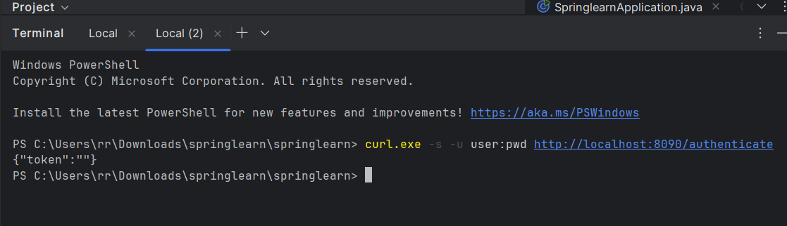
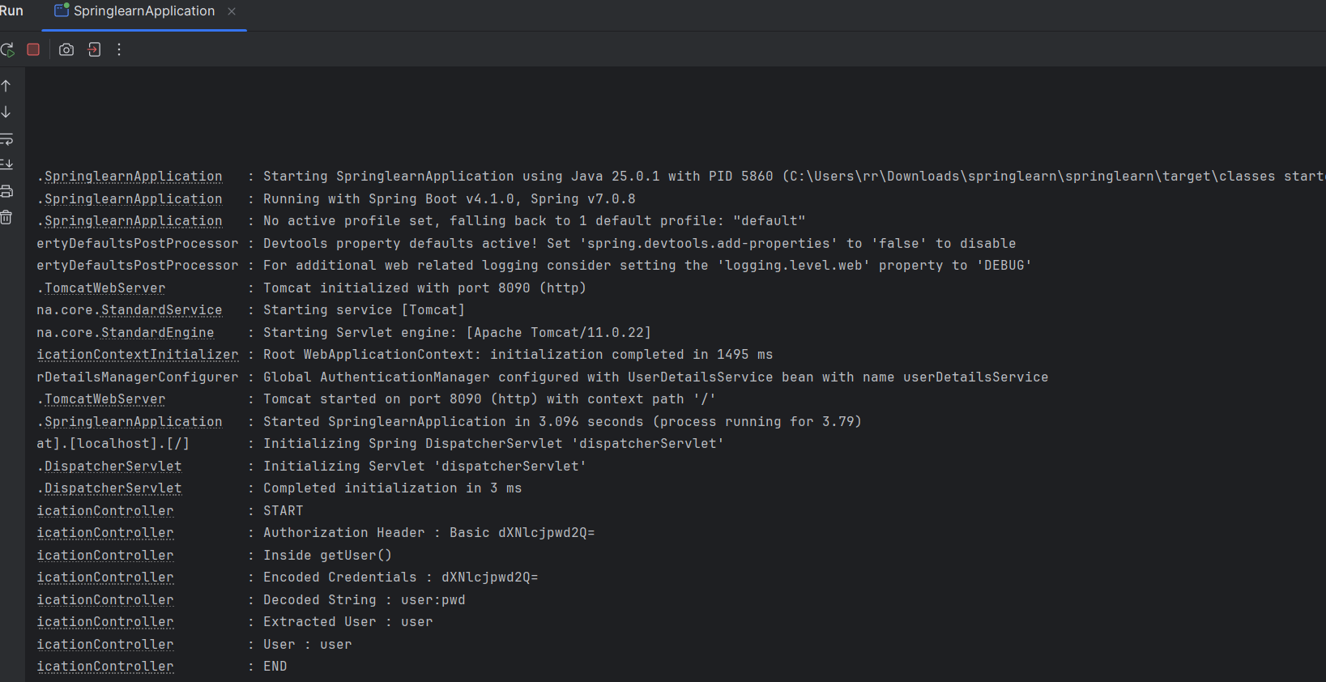

5) 3-Generate token based on the user
SpringlearnApplication.java:
package com.cognizant.springlearn;
import org.springframework.boot.SpringApplication;
import org.springframework.boot.autoconfigure.SpringBootApplication;
@SpringBootApplication
public class SpringlearnApplication {
public static void main(String[] args) {
SpringApplication.run(SpringlearnApplication.class, args);
}
}

AuthenticationController.java:
package com.cognizant.springlearn.controller;
import java.nio.charset.StandardCharsets;
import java.util.Base64;
import java.util.Date;
import java.util.HashMap;
import java.util.Map;
import org.slf4j.Logger;
import org.slf4j.LoggerFactory;
import org.springframework.web.bind.annotation.GetMapping;
import org.springframework.web.bind.annotation.RequestHeader;
import org.springframework.web.bind.annotation.RestController;
import io.jsonwebtoken.JwtBuilder;
import io.jsonwebtoken.Jwts;
import io.jsonwebtoken.SignatureAlgorithm;
@RestController
public class AuthenticationController {
private static final Logger LOGGER =
LoggerFactory.getLogger(AuthenticationController.class);
@GetMapping("/authenticate")
public Map<String, String> authenticate(
@RequestHeader("Authorization") String authHeader) {
LOGGER.info("START");
LOGGER.debug("Authorization Header : {}", authHeader);
// Get username
String user = getUser(authHeader);
LOGGER.debug("User : {}", user);
// Generate JWT
String token = generateJwt(user);
LOGGER.debug("Generated Token : {}", token);
Map<String, String> map = new HashMap<>();
map.put("token", token);
LOGGER.info("END");
return map;
}
private String getUser(String authHeader) {
LOGGER.debug("Inside getUser()");
String encodedCredentials = authHeader.substring(6);
LOGGER.debug("Encoded Credentials : {}", encodedCredentials);
byte[] decodedBytes =
Base64.getDecoder().decode(encodedCredentials);
String decodedString =
new String(decodedBytes, StandardCharsets.UTF_8);
LOGGER.debug("Decoded String : {}", decodedString);
String user =
decodedString.substring(0, decodedString.indexOf(":"));
LOGGER.debug("Extracted User : {}", user);
return user;
}
private String generateJwt(String user) {
LOGGER.debug("Inside generateJwt()");
JwtBuilder builder = Jwts.builder();
builder.setSubject(user);
// Current time
builder.setIssuedAt(new Date());
// Expiry after 20 minutes
builder.setExpiration(new Date(new Date().getTime() + 1200000));
builder.signWith(SignatureAlgorithm.HS256, "secretkey");
String token = builder.compact();
return token;
}
}

SecurityConfig.java:
package com.cognizant.springlearn.config;
import org.springframework.context.annotation.Bean;
import org.springframework.context.annotation.Configuration;
import org.springframework.security.config.Customizer;
import org.springframework.security.config.annotation.web.builders.HttpSecurity;
import org.springframework.security.core.userdetails.User;
import org.springframework.security.core.userdetails.UserDetails;
import org.springframework.security.provisioning.InMemoryUserDetailsManager;
import org.springframework.security.web.SecurityFilterChain;
@Configuration
public class SecurityConfig {
@Bean
public InMemoryUserDetailsManager userDetailsService() {
UserDetails user = User.withUsername("user")
.password("{noop}pwd")
.roles("USER")
.build();
UserDetails admin = User.withUsername("admin")
.password("{noop}pwd")
.roles("ADMIN")
.build();
return new InMemoryUserDetailsManager(user, admin);
}
@Bean
public SecurityFilterChain filterChain(HttpSecurity http)
throws Exception {
http.csrf(csrf -> csrf.disable())
.authorizeHttpRequests(auth -> auth
.requestMatchers("/countries").hasRole("USER")
.requestMatchers("/authenticate")
.hasAnyRole("USER", "ADMIN")
.anyRequest().authenticated())
.httpBasic(Customizer.withDefaults());
return http.build();
}
}

Output:
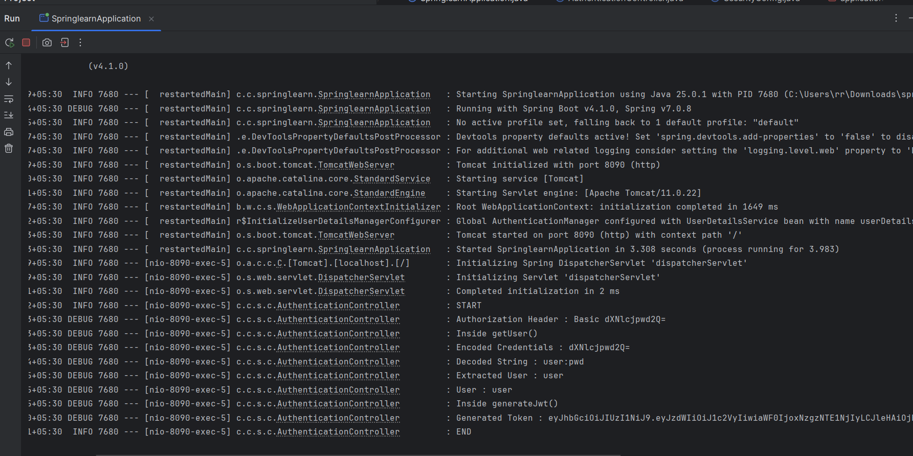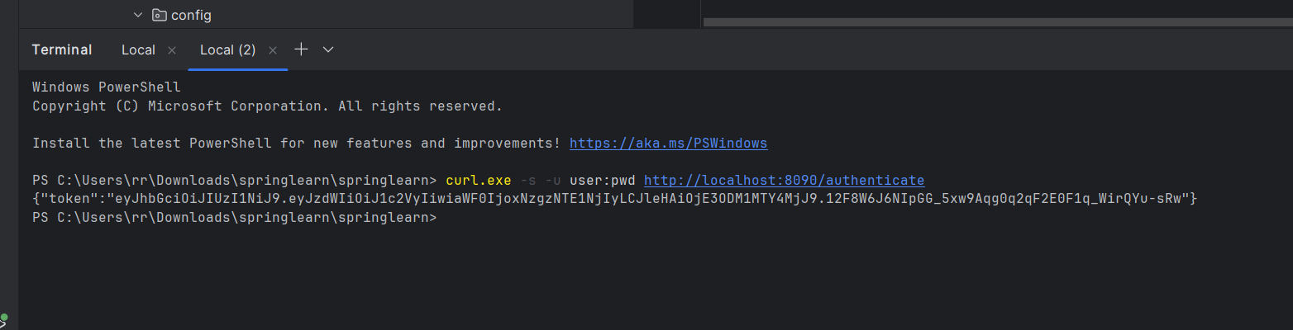

3)Spring-rest-handson:
1-Problem Statement - Display Employee List and Edit Employee form using RESTful Web Service
SpringLearnApplication.java:
package com.cognizant.springlearn;
import org.springframework.boot.SpringApplication;
import org.springframework.boot.autoconfigure.SpringBootApplication;
@SpringBootApplication
public class SpringLearnApplication {
public static void main(String[] args) {
SpringApplication.run(SpringLearnApplication.class, args);
}
}

EmployeeController.java:
package com.cognizant.springlearn.controller;
import com.cognizant.springlearn.model.Employee;
import com.cognizant.springlearn.service.EmployeeService;
import org.springframework.beans.factory.annotation.Autowired;
import org.springframework.web.bind.annotation.*;
import java.util.List;
@RestController
public class EmployeeController {
@Autowired
EmployeeService service;
@GetMapping("/employees")
public List<Employee> getEmployees() {
return service.getEmployees();
}
}

EmployeeService.java:
package com.cognizant.springlearn.service;
import com.cognizant.springlearn.dao.EmployeeDao;
import com.cognizant.springlearn.model.Employee;
import org.springframework.beans.factory.annotation.Autowired;
import org.springframework.stereotype.Service;
import java.util.List;
@Service
public class EmployeeService {
@Autowired
EmployeeDao dao;
public List<Employee> getEmployees() {
return dao.getAllEmployees();
}
}

EmployeeDao.java:
package com.cognizant.springlearn.dao;
import com.cognizant.springlearn.model.Employee;
import org.springframework.context.ApplicationContext;
import org.springframework.context.support.ClassPathXmlApplicationContext;
import org.springframework.stereotype.Repository;
import java.util.ArrayList;
import java.util.List;
@Repository
public class EmployeeDao {
public List<Employee> getAllEmployees() {
ApplicationContext context =
new ClassPathXmlApplicationContext("employee.xml");
List<Employee> list = new ArrayList<>();
list.add(context.getBean("employee1", Employee.class));
list.add(context.getBean("employee2", Employee.class));
return list;
}
}

Employee.java:
package com.cognizant.springlearn.model;
public class Employee {
private int id;
private String name;
private double salary;
private boolean permanent;
public Employee() {
}
public Employee(int id, String name, double salary, boolean permanent) {
this.id = id;
this.name = name;
this.salary = salary;
this.permanent = permanent;
}
public int getId() {
return id;
}
public void setId(int id) {
this.id = id;
}
public String getName() {
return name;
}
public void setName(String name) {
this.name = name;
}
public double getSalary() {
return salary;
}
public void setSalary(double salary) {
this.salary = salary;
}
public boolean isPermanent() {
return permanent;
}
public void setPermanent(boolean permanent) {
this.permanent = permanent;
}
}

employee.xml:
<?xml version="1.0" encoding="UTF-8"?>
<beans xmlns="http://www.springframework.org/schema/beans"
xmlns:xsi="http://www.w3.org/2001/XMLSchema-instance"
xsi:schemaLocation="
http://www.springframework.org/schema/beans
https://www.springframework.org/schema/beans/spring-beans.xsd">
<bean id="employee1" class="com.cognizant.springlearn.model.Employee">
<property name="id" value="101"/>
<property name="name" value="Naveen Kumar"/>
<property name="salary" value="50000"/>
<property name="permanent" value="true"/>
</bean>
<bean id="employee2" class="com.cognizant.springlearn.model.Employee">
<property name="id" value="102"/>
<property name="name" value="Rahul"/>
<property name="salary" value="45000"/>
<property name="permanent" value="false"/>
</bean>
</beans>

Output:
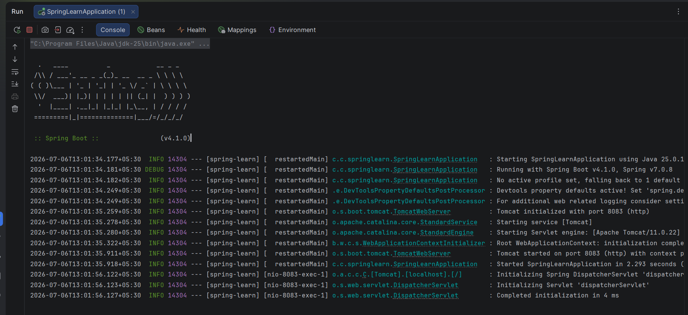
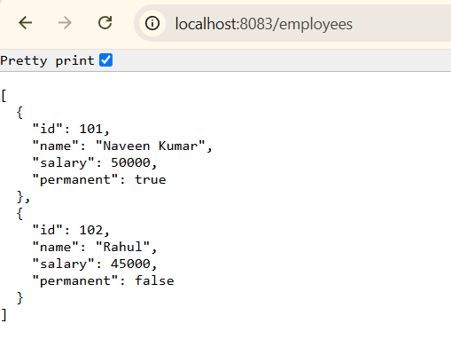

3) Spring-rest-handson:
2-Create static employee list data using spring xml configuration
EmployeeController:
package com.cognizant.springlearn.controller;
import com.cognizant.springlearn.model.Employee;
import com.cognizant.springlearn.service.EmployeeService;
import org.springframework.beans.factory.annotation.Autowired;
import org.springframework.web.bind.annotation.GetMapping;
import org.springframework.web.bind.annotation.RestController;
import java.util.ArrayList;
@RestController
public class EmployeeController {
@Autowired
EmployeeService employeeService;
@GetMapping("/employees")
public ArrayList<Employee> getEmployees() {
return employeeService.getAllEmployees();
}
}

EmployeeDao.java:
package com.cognizant.springlearn.dao;
import com.cognizant.springlearn.model.Employee;
import org.springframework.context.support.ClassPathXmlApplicationContext;
import org.springframework.stereotype.Repository;
import java.util.ArrayList;
@Repository
public class EmployeeDao {
private static ArrayList<Employee> EMPLOYEE_LIST;
public EmployeeDao() {
ClassPathXmlApplicationContext context =
new ClassPathXmlApplicationContext("employee.xml");
EMPLOYEE_LIST = (ArrayList<Employee>) context.getBean("employeeList");
}
public ArrayList<Employee> getAllEmployees() {
return EMPLOYEE_LIST;
}
}

Department.java:
package com.cognizant.springlearn.model;
public class Department {
private int id;
private String name;
public Department() {
}
public Department(int id, String name) {
this.id = id;
this.name = name;
}
public int getId() {
return id;
}
public void setId(int id) {
this.id = id;
}
public String getName() {
return name;
}
public void setName(String name) {
this.name = name;
}
@Override
public String toString() {
return "Department [id=" + id + ", name=" + name + "]";
}
}

Employee.java:
package com.cognizant.springlearn.model;
import java.util.List;
public class Employee {
private int id;
private String name;
private double salary;
private boolean permanent;
private Department department;
private List<Skill> skills;
public Employee() {
}
public Employee(int id, String name, double salary, boolean permanent,
Department department, List<Skill> skills) {
this.id = id;
this.name = name;
this.salary = salary;
this.permanent = permanent;
this.department = department;
this.skills = skills;
}
public int getId() {
return id;
}
public void setId(int id) {
this.id = id;
}
public String getName() {
return name;
}
public void setName(String name) {
this.name = name;
}
public double getSalary() {
return salary;
}
public void setSalary(double salary) {
this.salary = salary;
}
public boolean isPermanent() {
return permanent;
}
public void setPermanent(boolean permanent) {
this.permanent = permanent;
}
public Department getDepartment() {
return department;
}
public void setDepartment(Department department) {
this.department = department;
}
public List<Skill> getSkills() {
return skills;
}
public void setSkills(List<Skill> skills) {
this.skills = skills;
}
@Override
public String toString() {
return "Employee [id=" + id +
", name=" + name +
", salary=" + salary +
", permanent=" + permanent +
", department=" + department +
", skills=" + skills + "]";
}
}

Skill.java:
package com.cognizant.springlearn.model;
public class Skill {
private int id;
private String name;
public Skill() {
}
public Skill(int id, String name) {
this.id = id;
this.name = name;
}
public int getId() {
return id;
}
public void setId(int id) {
this.id = id;
}
public String getName() {
return name;
}
public void setName(String name) {
this.name = name;
}
@Override
public String toString() {
return "Skill [id=" + id + ", name=" + name + "]";
}
}

EmployeeService.java:
package com.cognizant.springlearn.service;
import com.cognizant.springlearn.dao.EmployeeDao;
import com.cognizant.springlearn.model.Employee;
import org.springframework.beans.factory.annotation.Autowired;
import org.springframework.stereotype.Service;
import java.util.ArrayList;
@Service
public class EmployeeService {
@Autowired
EmployeeDao employeeDao;
public ArrayList<Employee> getAllEmployees() {
return employeeDao.getAllEmployees();
}
}

SpringLearnApplication.java:
package com.cognizant.springlearn;
import org.springframework.boot.SpringApplication;
import org.springframework.boot.autoconfigure.SpringBootApplication;
@SpringBootApplication
public class SpringLearnApplication {
public static void main(String[] args) {
SpringApplication.run(SpringLearnApplication.class, args);
}
}

employee.xml:
<?xml version="1.0" encoding="UTF-8"?>
<beans xmlns="http://www.springframework.org/schema/beans"
xmlns:xsi="http://www.w3.org/2001/XMLSchema-instance"
xsi:schemaLocation="
http://www.springframework.org/schema/beans
http://www.springframework.org/schema/beans/spring-beans.xsd">
<!-- Departments -->
<bean id="dept1" class="com.cognizant.springlearn.model.Department">
<property name="id" value="1"/>
<property name="name" value="HR"/>
</bean>
<bean id="dept2" class="com.cognizant.springlearn.model.Department">
<property name="id" value="2"/>
<property name="name" value="IT"/>
</bean>
<bean id="dept3" class="com.cognizant.springlearn.model.Department">
<property name="id" value="3"/>
<property name="name" value="Finance"/>
</bean>
<!-- Skills -->
<bean id="skill1" class="com.cognizant.springlearn.model.Skill">
<property name="id" value="1"/>
<property name="name" value="Java"/>
</bean>
<bean id="skill2" class="com.cognizant.springlearn.model.Skill">
<property name="id" value="2"/>
<property name="name" value="Angular"/>
</bean>
<!-- Employees -->
<bean id="emp1" class="com.cognizant.springlearn.model.Employee">
<property name="id" value="1"/>
<property name="name" value="John"/>
<property name="salary" value="50000"/>
<property name="permanent" value="true"/>
<property name="department" ref="dept1"/>
<property name="skills">
<list>
<ref bean="skill1"/>
<ref bean="skill2"/>
</list>
</property>
</bean>
<bean id="emp2" class="com.cognizant.springlearn.model.Employee">
<property name="id" value="2"/>
<property name="name" value="David"/>
<property name="salary" value="60000"/>
<property name="permanent" value="true"/>
<property name="department" ref="dept2"/>
<property name="skills">
<list>
<ref bean="skill1"/>
</list>
</property>
</bean>
<bean id="emp3" class="com.cognizant.springlearn.model.Employee">
<property name="id" value="3"/>
<property name="name" value="Mary"/>
<property name="salary" value="45000"/>
<property name="permanent" value="false"/>
<property name="department" ref="dept3"/>
<property name="skills">
<list>
<ref bean="skill2"/>
</list>
</property>
</bean>
<bean id="emp4" class="com.cognizant.springlearn.model.Employee">
<property name="id" value="4"/>
<property name="name" value="Sam"/>
<property name="salary" value="70000"/>
<property name="permanent" value="true"/>
<property name="department" ref="dept2"/>
<property name="skills">
<list>
<ref bean="skill1"/>
<ref bean="skill2"/>
</list>
</property>
</bean>
<bean id="emp5" class="com.cognizant.springlearn.model.Employee">
<property name="id" value="5"/>
<property name="name" value="Robert"/>
<property name="salary" value="90000"/>
<property name="permanent" value="true"/>
<property name="department" ref="dept1"/>
<property name="skills">
<list>
<ref bean="skill2"/>
</list>
</property>
</bean>
<!-- Employee List -->
<bean id="employeeList" class="java.util.ArrayList">
<constructor-arg>
<list>
<ref bean="emp1"/>
<ref bean="emp2"/>
<ref bean="emp3"/>
<ref bean="emp4"/>
<ref bean="emp5"/>
</list>
</constructor-arg>
</bean>
</beans>

Output:
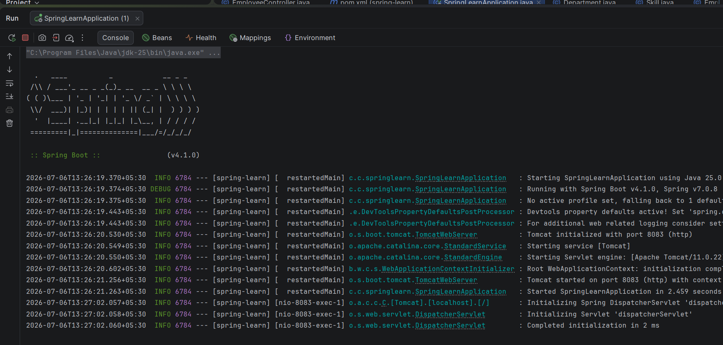

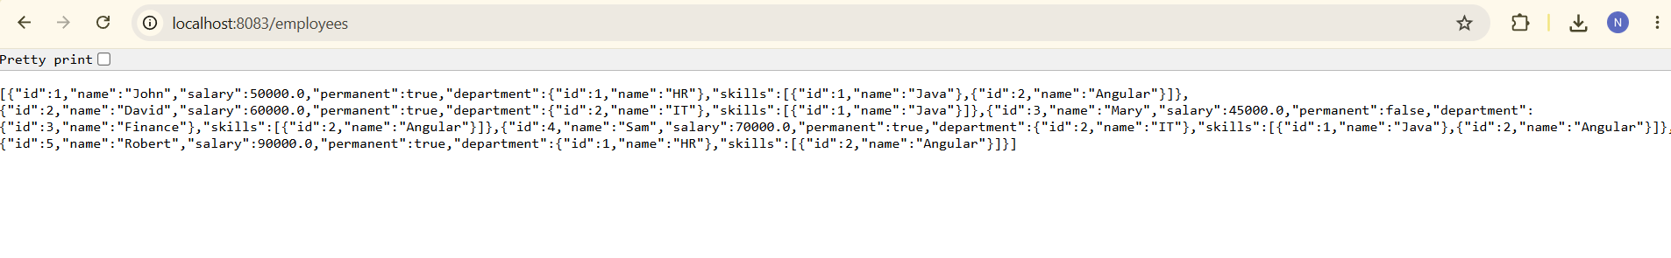
3) Spring-rest-handson:
3-Create REST service to gets all employees
EmployeeController.java:
package com.cognizant.springlearn.controller;
import java.util.ArrayList;
import org.springframework.beans.factory.annotation.Autowired;
import org.springframework.web.bind.annotation.GetMapping;
import org.springframework.web.bind.annotation.RestController;
import com.cognizant.springlearn.model.Employee;
import com.cognizant.springlearn.service.EmployeeService;
@RestController
public class EmployeeController {
@Autowired
private EmployeeService employeeService;
@GetMapping("/employees")
public ArrayList<Employee> getAllEmployees() {
return employeeService.getAllEmployees();
}
}

EmployeeDao:
package com.cognizant.springlearn.dao;
import java.util.ArrayList;
import org.springframework.context.support.ClassPathXmlApplicationContext;
import org.springframework.stereotype.Repository;
import com.cognizant.springlearn.model.Employee;
@Repository
public class EmployeeDao {
private static ArrayList<Employee> EMPLOYEE_LIST;
@SuppressWarnings("unchecked")
public EmployeeDao() {
ClassPathXmlApplicationContext context =
new ClassPathXmlApplicationContext("employee.xml");
EMPLOYEE_LIST =
(ArrayList<Employee>) context.getBean("employeeList");
}
public ArrayList<Employee> getAllEmployees() {
return EMPLOYEE_LIST;
}
}

Department.java:
package com.cognizant.springlearn.model;
public class Department {
private int id;
private String name;
public Department() {
}
public Department(int id, String name) {
this.id = id;
this.name = name;
}
public int getId() {
return id;
}
public void setId(int id) {
this.id = id;
}
public String getName() {
return name;
}
public void setName(String name) {
this.name = name;
}
@Override
public String toString() {
return "Department [id=" + id + ", name=" + name + "]";
}
}

Employee.java:
package com.cognizant.springlearn.model;
import java.util.List;
public class Employee {
private int id;
private String name;
private double salary;
private boolean permanent;
private Department department;
private List<Skill> skills;
public Employee() {
}
public Employee(int id, String name, double salary, boolean permanent,
Department department, List<Skill> skills) {
this.id = id;
this.name = name;
this.salary = salary;
this.permanent = permanent;
this.department = department;
this.skills = skills;
}
public int getId() {
return id;
}
public void setId(int id) {
this.id = id;
}
public String getName() {
return name;
}
public void setName(String name) {
this.name = name;
}
public double getSalary() {
return salary;
}
public void setSalary(double salary) {
this.salary = salary;
}
public boolean isPermanent() {
return permanent;
}
public void setPermanent(boolean permanent) {
this.permanent = permanent;
}
public Department getDepartment() {
return department;
}
public void setDepartment(Department department) {
this.department = department;
}
public List<Skill> getSkills() {
return skills;
}
public void setSkills(List<Skill> skills) {
this.skills = skills;
}
@Override
public String toString() {
return "Employee [id=" + id +
", name=" + name +
", salary=" + salary +
", permanent=" + permanent +
", department=" + department +
", skills=" + skills + "]";
}
}

Skill.java:
package com.cognizant.springlearn.model;
public class Skill {
private int id;
private String name;
public Skill() {
}
public Skill(int id, String name) {
this.id = id;
this.name = name;
}
public int getId() {
return id;
}
public void setId(int id) {
this.id = id;
}
public String getName() {
return name;
}
public void setName(String name) {
this.name = name;
}
@Override
public String toString() {
return "Skill [id=" + id + ", name=" + name + "]";
}
}

EmployeeService.java:
package com.cognizant.springlearn.service;
import java.util.ArrayList;
import org.springframework.beans.factory.annotation.Autowired;
import org.springframework.stereotype.Service;
import org.springframework.transaction.annotation.Transactional;
import com.cognizant.springlearn.dao.EmployeeDao;
import com.cognizant.springlearn.model.Employee;
@Service
public class EmployeeService {
@Autowired
private EmployeeDao employeeDao;
@Transactional
public ArrayList<Employee> getAllEmployees() {
return employeeDao.getAllEmployees();
}
}

SpringLearnApplication.java:
package com.cognizant.springlearn;
import org.springframework.boot.SpringApplication;
import org.springframework.boot.autoconfigure.SpringBootApplication;
@SpringBootApplication
public class SpringLearnApplication {
public static void main(String[] args) {
SpringApplication.run(SpringLearnApplication.class, args);
}
}

pom.xml:
<?xml version="1.0" encoding="UTF-8"?>
<project xmlns="http://maven.apache.org/POM/4.0.0"
xmlns:xsi="http://www.w3.org/2001/XMLSchema-instance"
xsi:schemaLocation="http://maven.apache.org/POM/4.0.0
https://maven.apache.org/xsd/maven-4.0.0.xsd">
<modelVersion>4.0.0</modelVersion>
<parent>
<groupId>org.springframework.boot</groupId>
<artifactId>spring-boot-starter-parent</artifactId>
<version>3.5.4</version>
<relativePath/>
</parent>
<groupId>com.cognizant</groupId>
<artifactId>spring-learn</artifactId>
<version>0.0.1-SNAPSHOT</version>
<name>spring-learn</name>
<description>Spring Learn</description>
<properties>
<java.version>21</java.version>
</properties>
<dependencies>
<dependency>
<groupId>org.springframework.boot</groupId>
<artifactId>spring-boot-starter-web</artifactId>
</dependency>
<dependency>
<groupId>org.springframework</groupId>
<artifactId>spring-tx</artifactId>
</dependency>
<dependency>
<groupId>org.springframework.boot</groupId>
<artifactId>spring-boot-devtools</artifactId>
<scope>runtime</scope>
<optional>true</optional>
</dependency>
<dependency>
<groupId>org.springframework.boot</groupId>
<artifactId>spring-boot-starter-test</artifactId>
<scope>test</scope>
</dependency>
</dependencies>
<build>
<plugins>
<plugin>
<groupId>org.springframework.boot</groupId>
<artifactId>spring-boot-maven-plugin</artifactId>
</plugin>
</plugins>
</build>
</project>

Output:
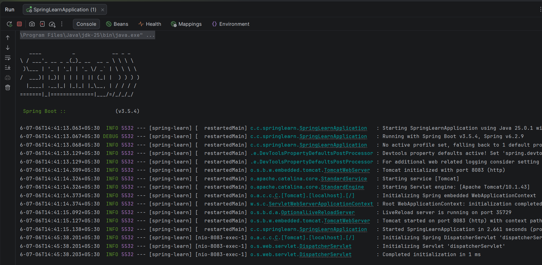

PostMan Output:
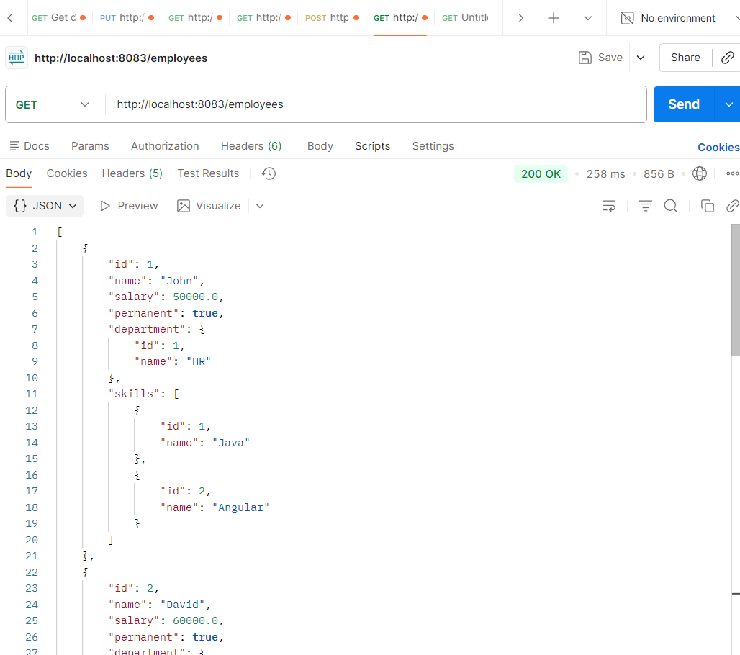
3) Spring-rest-handson:
4-Create REST service for department
DepartmentController.java:
package com.cognizant.springlearn.controller;
import com.cognizant.springlearn.model.Department;
import com.cognizant.springlearn.service.DepartmentService;
import org.springframework.beans.factory.annotation.Autowired;
import org.springframework.web.bind.annotation.GetMapping;
import org.springframework.web.bind.annotation.RestController;
import java.util.List;
@RestController
public class DepartmentController {
@Autowired
private DepartmentService departmentService;
@GetMapping("/departments")
public List<Department> getAllDepartments() {
System.out.println("Department REST Service Called");
return departmentService.getAllDepartments();
}
}

EmployeeController.java:
package com.cognizant.springlearn.controller;
import java.util.ArrayList;
import org.springframework.beans.factory.annotation.Autowired;
import org.springframework.web.bind.annotation.GetMapping;
import org.springframework.web.bind.annotation.RestController;
import com.cognizant.springlearn.model.Employee;
import com.cognizant.springlearn.service.EmployeeService;
@RestController
public class EmployeeController {
@Autowired
private EmployeeService employeeService;
@GetMapping("/employees")
public ArrayList<Employee> getAllEmployees() {
return employeeService.getAllEmployees();
}
}

DepartmentDao.java:
package com.cognizant.springlearn.dao;
import com.cognizant.springlearn.model.Department;
import org.springframework.stereotype.Repository;
import java.util.List;
@Repository
public class DepartmentDao {
private static List<Department> DEPARTMENT_LIST;
public static List<Department> getDepartmentList() {
return DEPARTMENT_LIST;
}
public static void setDepartmentList(List<Department> departmentList) {
DEPARTMENT_LIST = departmentList;
}
public List<Department> getAllDepartments() {
return DEPARTMENT_LIST;
}
}

EmployeeDao.java:
package com.cognizant.springlearn.dao;
import java.util.ArrayList;
import org.springframework.context.support.ClassPathXmlApplicationContext;
import org.springframework.stereotype.Repository;
import com.cognizant.springlearn.model.Employee;
@Repository
public class EmployeeDao {
private static ArrayList<Employee> EMPLOYEE_LIST;
@SuppressWarnings("unchecked")
public EmployeeDao() {
ClassPathXmlApplicationContext context =
new ClassPathXmlApplicationContext("employee.xml");
EMPLOYEE_LIST =
(ArrayList<Employee>) context.getBean("employeeList");
}
public ArrayList<Employee> getAllEmployees() {
return EMPLOYEE_LIST;
}
}

Department.java:
package com.cognizant.springlearn.model;
public class Department {
private int id;
private String name;
public Department() {
}
public Department(int id, String name) {
this.id = id;
this.name = name;
}
public int getId() {
return id;
}
public void setId(int id) {
this.id = id;
}
public String getName() {
return name;
}
public void setName(String name) {
this.name = name;
}
@Override
public String toString() {
return "Department [id=" + id + ", name=" + name + "]";
}
}

Employee.java:
package com.cognizant.springlearn.model;
import java.util.List;
public class Employee {
private int id;
private String name;
private double salary;
private boolean permanent;
private Department department;
private List<Skill> skills;
public Employee() {
}
public Employee(int id, String name, double salary, boolean permanent,
Department department, List<Skill> skills) {
this.id = id;
this.name = name;
this.salary = salary;
this.permanent = permanent;
this.department = department;
this.skills = skills;
}
public int getId() {
return id;
}
public void setId(int id) {
this.id = id;
}
public String getName() {
return name;
}
public void setName(String name) {
this.name = name;
}
public double getSalary() {
return salary;
}
public void setSalary(double salary) {
this.salary = salary;
}
public boolean isPermanent() {
return permanent;
}
public void setPermanent(boolean permanent) {
this.permanent = permanent;
}
public Department getDepartment() {
return department;
}
public void setDepartment(Department department) {
this.department = department;
}
public List<Skill> getSkills() {
return skills;
}
public void setSkills(List<Skill> skills) {
this.skills = skills;
}
@Override
public String toString() {
return "Employee [id=" + id +
", name=" + name +
", salary=" + salary +
", permanent=" + permanent +
", department=" + department +
", skills=" + skills + "]";
}
}

Skill.java:
package com.cognizant.springlearn.model;
public class Skill {
private int id;
private String name;
public Skill() {
}
public Skill(int id, String name) {
this.id = id;
this.name = name;
}
public int getId() {
return id;
}
public void setId(int id) {
this.id = id;
}
public String getName() {
return name;
}
public void setName(String name) {
this.name = name;
}
@Override
public String toString() {
return "Skill [id=" + id + ", name=" + name + "]";
}
}

DepartmentService.java:
package com.cognizant.springlearn.service;
import com.cognizant.springlearn.dao.DepartmentDao;
import com.cognizant.springlearn.model.Department;
import org.springframework.beans.factory.annotation.Autowired;
import org.springframework.stereotype.Service;
import org.springframework.transaction.annotation.Transactional;
import java.util.List;
@Service
public class DepartmentService {
@Autowired
private DepartmentDao departmentDao;
@Transactional
public List<Department> getAllDepartments() {
return departmentDao.getAllDepartments();
}
}

EmployeeService.java:
package com.cognizant.springlearn.service;
import java.util.ArrayList;
import org.springframework.beans.factory.annotation.Autowired;
import org.springframework.stereotype.Service;
import org.springframework.transaction.annotation.Transactional;
import com.cognizant.springlearn.dao.EmployeeDao;
import com.cognizant.springlearn.model.Employee;
@Service
public class EmployeeService {
@Autowired
private EmployeeDao employeeDao;
@Transactional
public ArrayList<Employee> getAllEmployees() {
return employeeDao.getAllEmployees();
}
}

SpringLearnApplication.java:
package com.cognizant.springlearn;
import org.springframework.boot.SpringApplication;
import org.springframework.boot.autoconfigure.SpringBootApplication;
@SpringBootApplication
public class SpringLearnApplication {
public static void main(String[] args) {
SpringApplication.run(SpringLearnApplication.class, args);
}
}

employee.xml:
<?xml version="1.0" encoding="UTF-8"?>
<beans xmlns="http://www.springframework.org/schema/beans"
xmlns:xsi="http://www.w3.org/2001/XMLSchema-instance"
xmlns:util="http://www.springframework.org/schema/util"
xsi:schemaLocation="
http://www.springframework.org/schema/beans
https://www.springframework.org/schema/beans/spring-beans.xsd
http://www.springframework.org/schema/util
https://www.springframework.org/schema/util/spring-util.xsd">
<util:list id="employeeList">
<bean class="com.cognizant.springlearn.model.Employee">
<property name="id" value="1"/>
<property name="name" value="John"/>
<property name="salary" value="50000"/>
</bean>
<bean class="com.cognizant.springlearn.model.Employee">
<property name="id" value="2"/>
<property name="name" value="David"/>
<property name="salary" value="60000"/>
</bean>
</util:list>
</beans>

Output:
